CHEMISTRY FOR ENGINEERS

ASSIGNMENT 29

Part I: MULTIPLE CHOICE QUESTIONS (5pts)

1. B. Valence electron meaning the electron at the most outside layer.
2. D. ClO3- have pyramidal geometry since it are 4 made of 3 bonds and 1 lone pair electron.
3. I. SO2 have VSPER equal 3 meaning it geometry is trigonal pyramidal, meaning indicated angle is around 120o, in this case it is 119o. The O-S-O bond angle is expected to be *less than* 120° because of the extra space taken up by the lone pair (repulsions).
4. D
5. B. to stable through achieve octet rule which similar to the valance e of noble gases.

Part II: CONSTRUCTED QUESTIONS (95pts)

1. Draw the three resonance structures of carbonate ion, CO32-. (6pts)

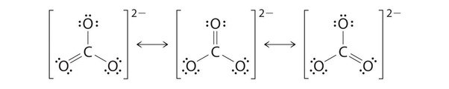

1. 2. Draw the three resonance structures of nitrate ion, NO3-. (6pts)

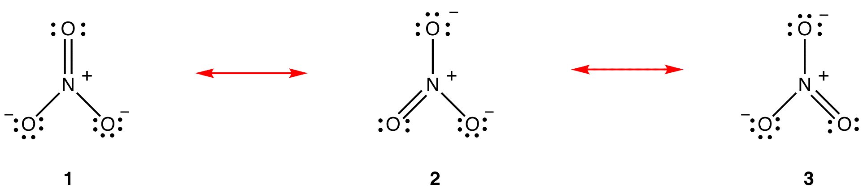

2. The difference in electronegativity between C and O is:

Since , the bond is **polar covalent**.

1. The difference in electronegativity between Ca and O is:

Since , the bond is **ionic**.

1. The difference in electronegativity between Na and Br is:

Since , the bond is **ionic**.

1. The difference in electronegativity between Mg and I is:

Since , the bond is **polar covalent**.

1. The difference in electronegativity between S and O is:

Since , the bond is **polar covalent**.

1. The difference in electronegativity between N and I is:

Since , the bond is **nonpolar covalent**.

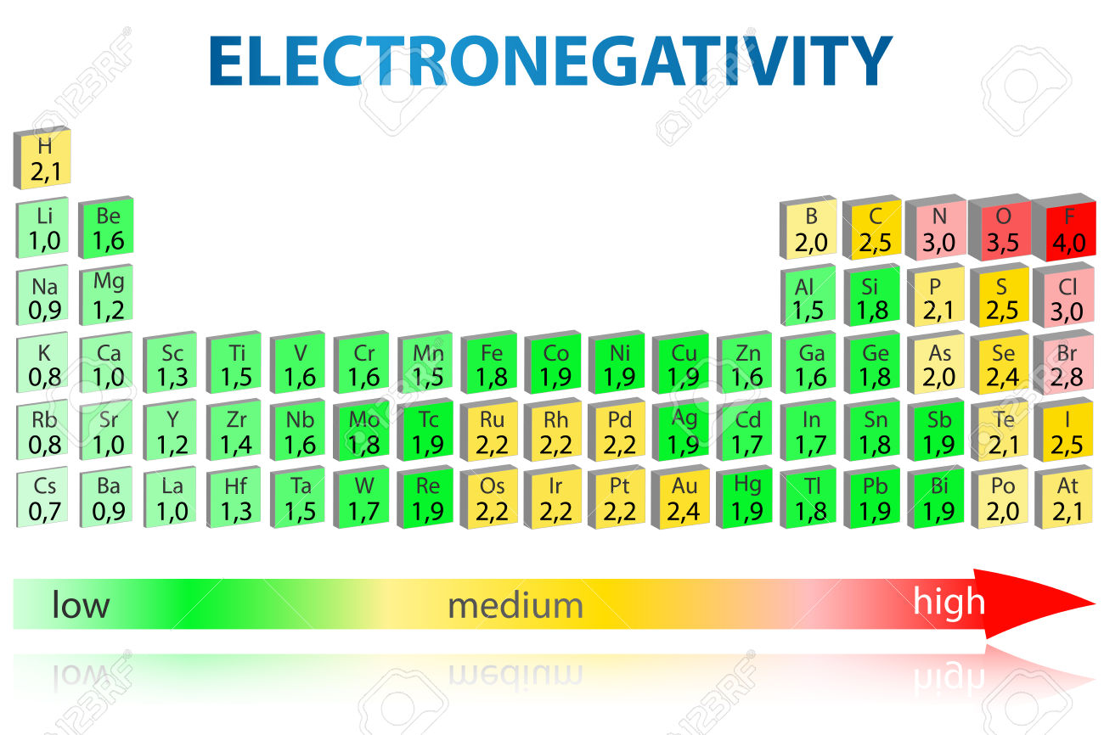





_ Shape of molecule: Linear

_Idealize bond angle: 180o

_ The molecule is nonpolar since the dipole moment is cancel each other.



_ Shape of molecule: trigonal pyramidal

_Idealize bond angle: <109.5o

_ The molecule is polar since the dipole moment is not equal zero.





_ Shape of molecule: Square pyramidal

_Idealize bond angle: <90o

_ The molecule is polar since the dipole moment is not equal zero.





_ Shape of molecule: Trigonal Planar

_Idealize bond angle: 120o

_ The molecule is polar since the dipole moment is not equal zero.





_ Shape of molecule: Tetrahedral

_Idealize bond angle: 109.5o

_ The molecule is polar since the dipole moment is not equal zero





_ Shape of molecule: linear

_Idealize bond angle: 180o

_ The molecule is polar since the dipole moment is not equal zero. The dipole moment between S and C is greater than between N and C since electronegativity of S is larger than N.





_ Shape of molecule: Trigonal Planar

_Idealize bond angle: 120o

_ The molecule is nonpolar since the dipole moment is cancel each other.





_ Shape of molecule: bent

_ Idealize bond angle: 109.5o

_ The molecule is polar since the dipole moment is not equal zero.



_ Intramolecular forces is the forces that exist **within** each molecules and influence the **chemical properties** of the substances. This forces is relatively **strong** since large charge molecules are puts close together.

_ Intermolecular forces is the forces that exist **between** each molecules and influence the **physical properties** of the substances. This forces is relatively **weak** (compare to intramolecular forces) since small charge molecules are farther apart.

_ Intermolecular force can be divide into four main types:

+ Dipole – dipole: This interaction are occur between positive and negative ends of two polar molecules

H2O < CH3OH < CH3OCH3

+ Hydrogen bonding: The interactions occur between hydrogen atom that covalently bond to high electronegativity atom (N, O, F) and lone pair of other high electronegativity atom (N, O, F)

NH3 < HCl < H2O

+ Ion – dipole: This interaction are occur between positive or negative ends of polar molecules with opposite charge ion.

Ex: between NH3, H2O, H2S with Na+

+ London Dispersion force: The interaction between 2 nonpolar molecule due to “temporary dipoles” are form cause the temporary attract or repel electron cloud of nearby nonpolar molecules.

CH4 < C2H5 < C3H7

1. Because intermolecular forces increase the **bonding strength between two or more molecules**, intermolecular forces can impact the melting and boiling points of compounds. In general, as intermolecular force **strength increases**, the melting and boiling points of a substance **also increase.**